Encryption Integration Plan
Enhancing Security in Messaging Applications
Spinnaker Analytics
25 June 2026

Table of Contents
- Introduction
- Encryption Architecture Overview
- Signal Protocol Integration
- Message Encryption Configuration
- File Transfer Encryption Configuration
- Voice Call Encryption Configuration
- Key Management and Exchange
- Perfect Forward Secrecy Implementation
- Encryption Testing and Validation
- Security Considerations
- Conclusion

1. Introduction

1.1 Purpose
- This document defines the implementation plan for integrating comprehensive encryption mechanisms into a messaging application.
- The proposed solution ensures confidentiality, integrity, authenticity, and forward secrecy across messaging, voice communications, and file transfers.
- The encryption architecture is based on the Signal Protocol and industry-standard cryptographic algorithms, providing protection against interception, unauthorized access, data tampering, and session compromise.

1.2 Objectives
The primary objectives of the encryption integration are:

- Implement end-to-end encryption for all communications
- Protect message confidentiality and integrity
- Secure voice calls using encrypted real-time protocols
- Protect file transfers during transmission and storage
- Establish secure cryptographic key management
- Enable Perfect Forward Secrecy (PFS)
- Prevent unauthorized access through strong authentication mechanisms

2. Encryption Architecture Overview
- The proposed architecture applies multiple layers of cryptographic protection. Application-layer encryption is provided by the Signal Protocol, while transport security is provided by TLS 1.3.
Figure 1 – Encryption Architecture Overview
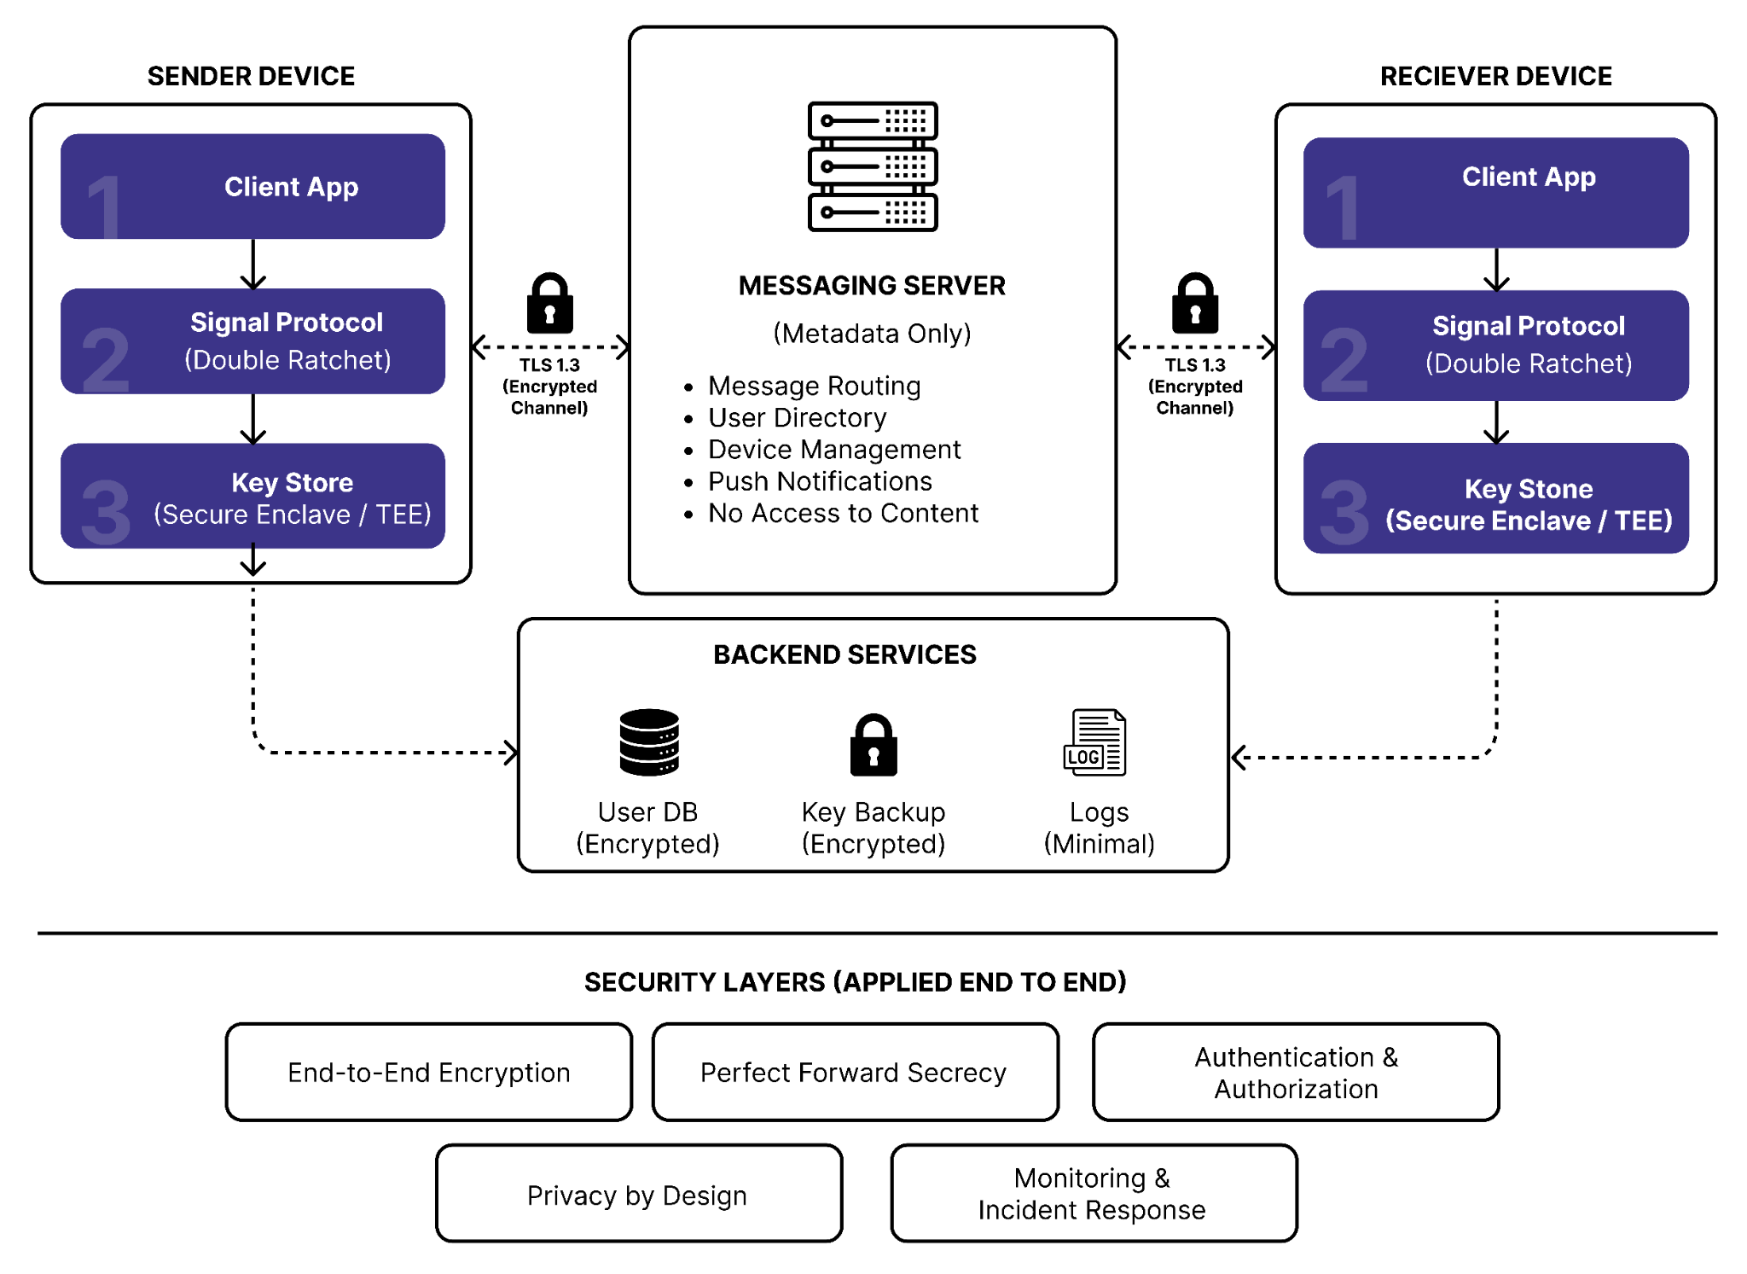

2.1 Encryption Components
Component | Technology
End-to-End Encryption | Signal Protocol
Key Exchange | X3DH
Session Management | Double Ratchet
Message Encryption | AES-256-GCM
File Encryption | AES-256-GCM
Integrity Verification | HMAC-SHA256
Transport Security | TLS 1.3
Voice Encryption | SRTP
Key Derivation | HKDF

Security Domain | Technology
Messaging | Signal Protocol
File Encryption | AES-256-GCM
Voice Security | SRTP
Transport Security | TLS 1.3
Key Exchange | X3DH
Key Rotation | Double Ratchet
Authentication | MFA + Biometrics
Monitoring | Wazuh
IDS/IPS | Suricata

2.2 Security Architecture Principles
- Zero-knowledge server architecture
- End-to-end encryption by default
- Perfect Forward Secrecy
- Secure key rotation
- Defense-in-depth
- Privacy-by-design

3. Signal Protocol Integration
Signal Protocol forms the foundation of the encryption architecture.
The protocol combines:
- X3DH Key Exchange
- Double Ratchet Algorithm
- Forward Secrecy
- Future Secrecy
- Mutual Authentication

3.1 Identity Key Pair
Each user receives a long-term identity key pair.

Parameter | Value
Algorithm | X25519
Key Size | 256-bit
Storage | Secure Enclave / TEE
Rotation | Manual Verification

Purpose
- Establish user identity
- Authenticate sessions
- Verify public keys

3.2 Signed Pre-Key
Purpose:
- Authenticated session establishment
- Prevent impersonation attacks
Configuration:

Parameter | Value
Algorithm | X25519
Rotation | 7 Days
Signature | Identity Key

3.3 One-Time Pre-Keys
One-Time Pre-Keys support asynchronous communication.
Configuration:

Parameter | Value
Initial Pool | 100 Keys
Minimum Threshold | 50 Keys
Refresh Method | Automatic Generation

Figure 2 – Signal Protocol Session Establishment

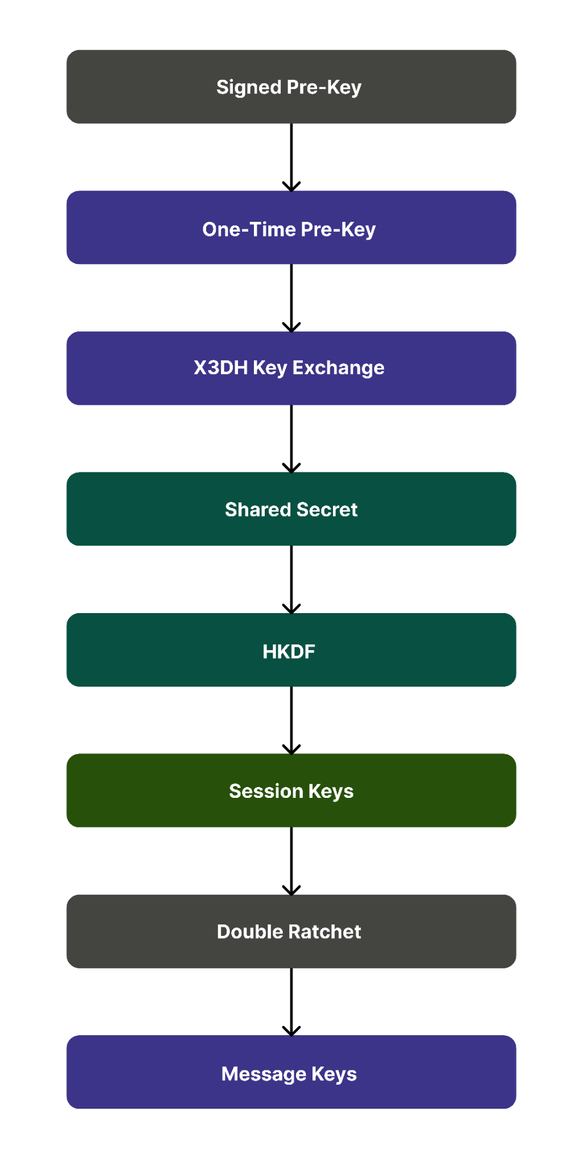

3.4 X3DH Key Exchange
The Extended Triple Diffie-Hellman protocol establishes an initial shared secret.
Process
- Retrieve recipient pre-keys
- Perform DH calculations
- Generate shared secret
- Derive root key via HKDF
- Initialize Double Ratchet
Benefits
- Mutual authentication
- Forward secrecy
- Resistance to replay attacks

4. Message Encryption Configuration
- Text messaging uses end-to-end encryption based on Signal Protocol and AES-256-GCM.

4.1 Encryption Workflow
- Step 1 – Message Composition
  - User creates plaintext message on the device.

Step 2 – Session Key Derivation
  - Double Ratchet derives a unique message key.

Step 3 – Encryption
  - Message encrypted using:
    - AES-256-GCM

Step 4 – Integrity Protection
  - Message integrity verified using:
    - HMAC-SHA256

Step 5 – Transmission
  - Ciphertext transmitted through:
    - TLS 1.3
Figure 3 – Secure Messaging Encryption Workflow
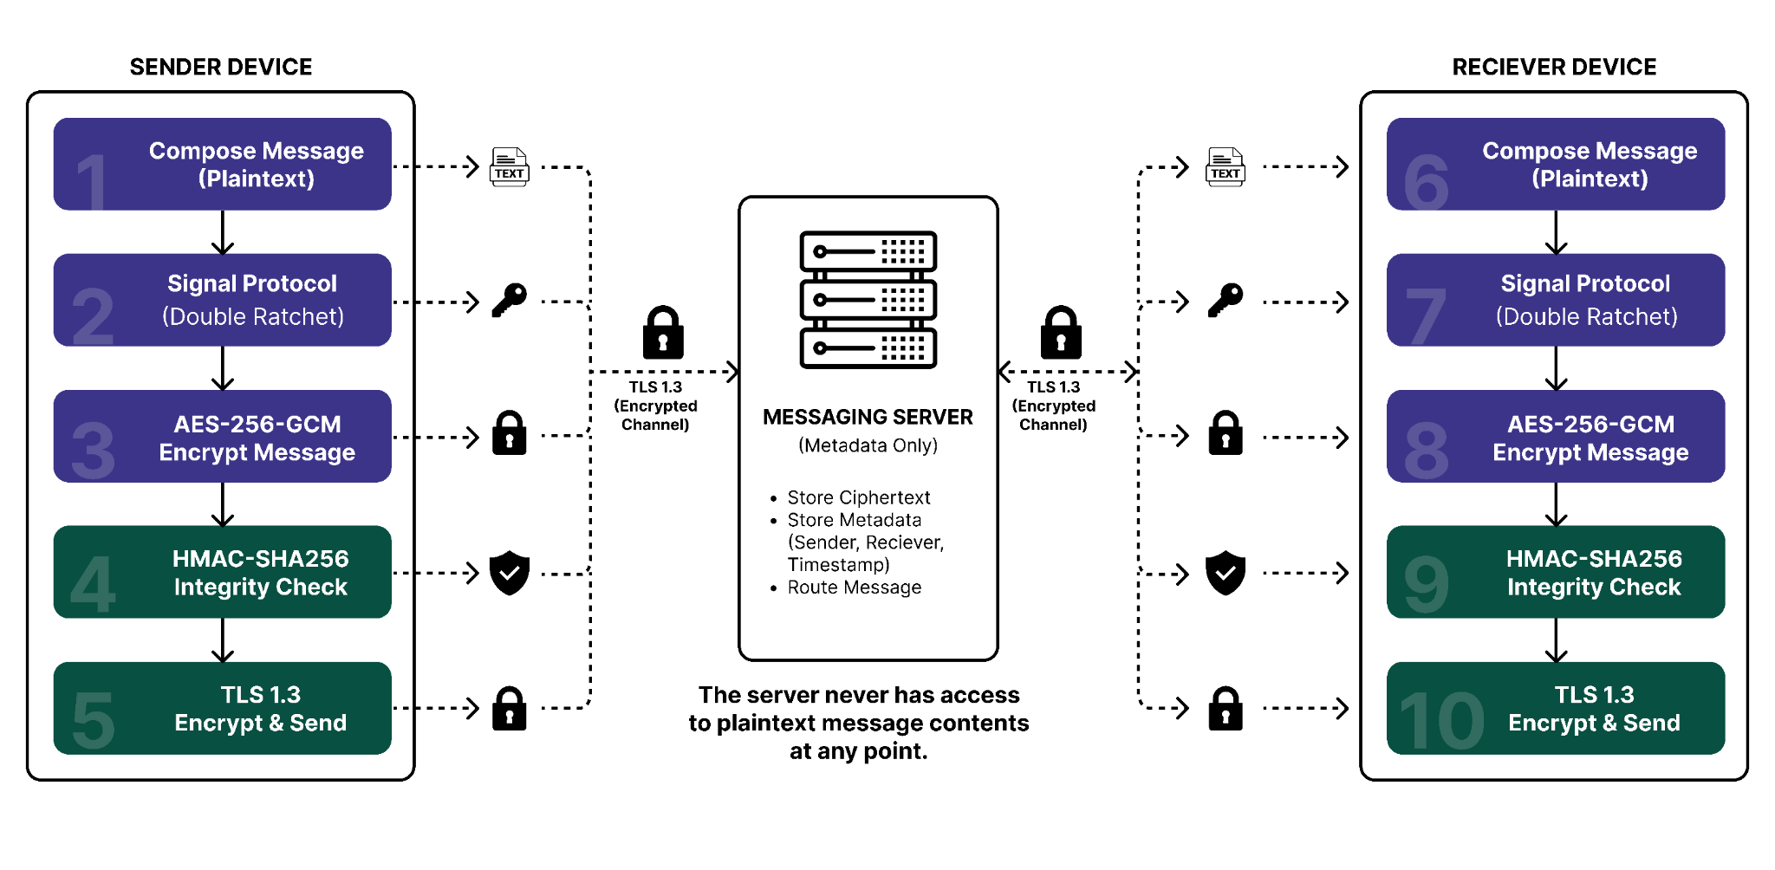

4.2 Encryption Parameters

Parameter | Value
Encryption Algorithm | AES-256-GCM
Key Length | 256-bit
Nonce Length | 96-bit
Authentication Tag | 128-bit
Hash Algorithm | SHA-256

4.3 Security Benefits
- Confidentiality
- Integrity
- Authentication
- Forward Secrecy
- Replay Protection

5. File Transfer Encryption Configuration
Files are encrypted prior to transmission and remain encrypted throughout storage and transfer.

5.1 Encryption Workflow
- User selects file
- Session key generated
- File encrypted using AES-256-GCM
- Integrity tag generated
- File transmitted over TLS 1.3
- Stored in encrypted storage
- Recipient decrypts locally

Figure 4 – Secure File Transfer Workflow
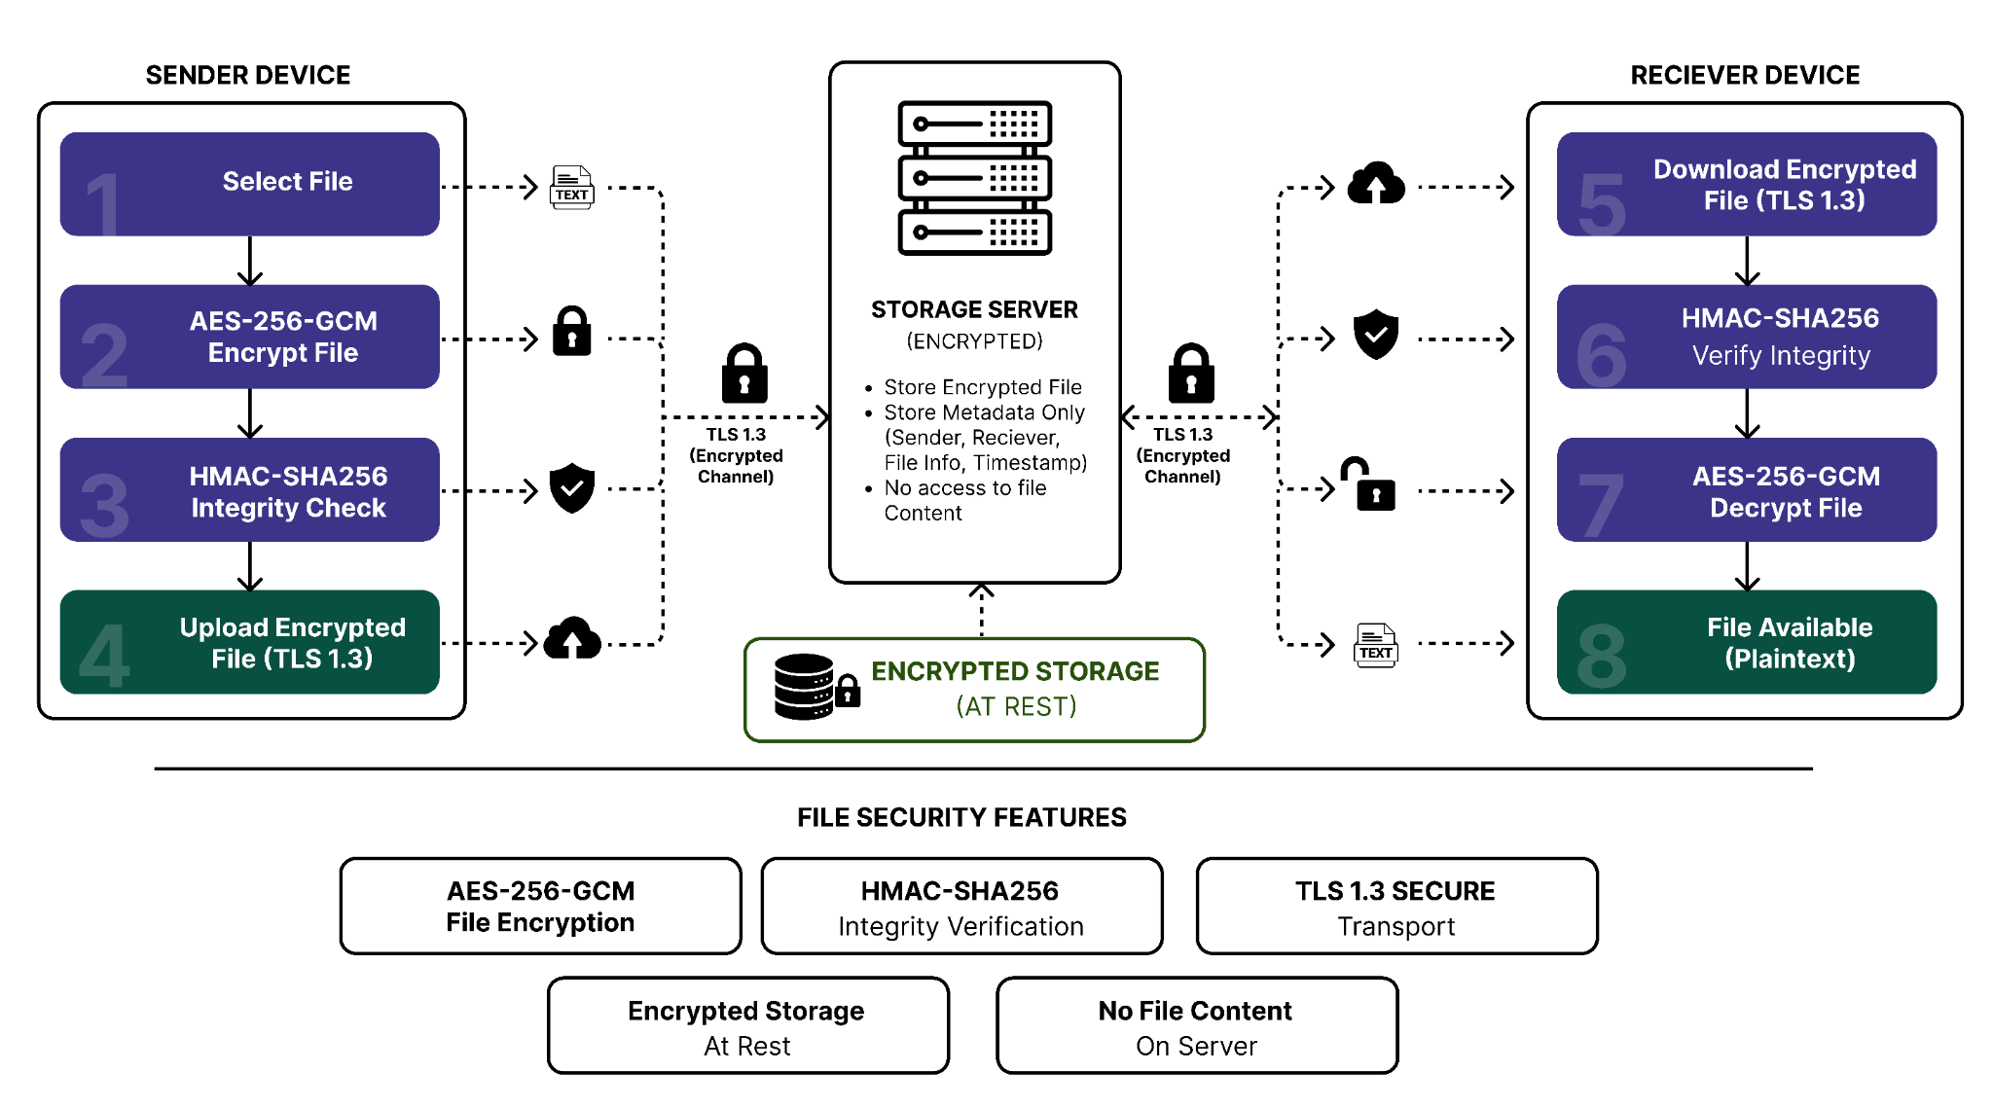

5.2 Encryption Parameters
Component | Technology
Encryption | AES-256-GCM
Nonce | 96-bit Random
Transport Security | TLS 1.3
Integrity Validation | HMAC-SHA256
Storage Security | SQLCipher

5.3 Secure Storage Configuration
- Client Device
  - SQLCipher Database
  - Full Disk Encryption
  - Secure Enclave Storage
- Server Side
  - Encrypted Storage
  - Metadata Separation
  - Encrypted Backups
- Security Benefits
  - Secure transmission
  - Secure storage
  - End-to-end confidentiality
  - Tamper detection

6. Voice Call Encryption Configuration
Voice calls are protected using SRTP and DTLS-SRTP.

6.1 Voice Encryption Stack

Layer | Technology
Signaling | TLS 1.3
Key Exchange | DTLS 1.2
Audio Transport | RTP
Voice Encryption | SRTP
Cipher Suite | AES-128-GCM

Figure 5 – Secure Voice Call Workflow
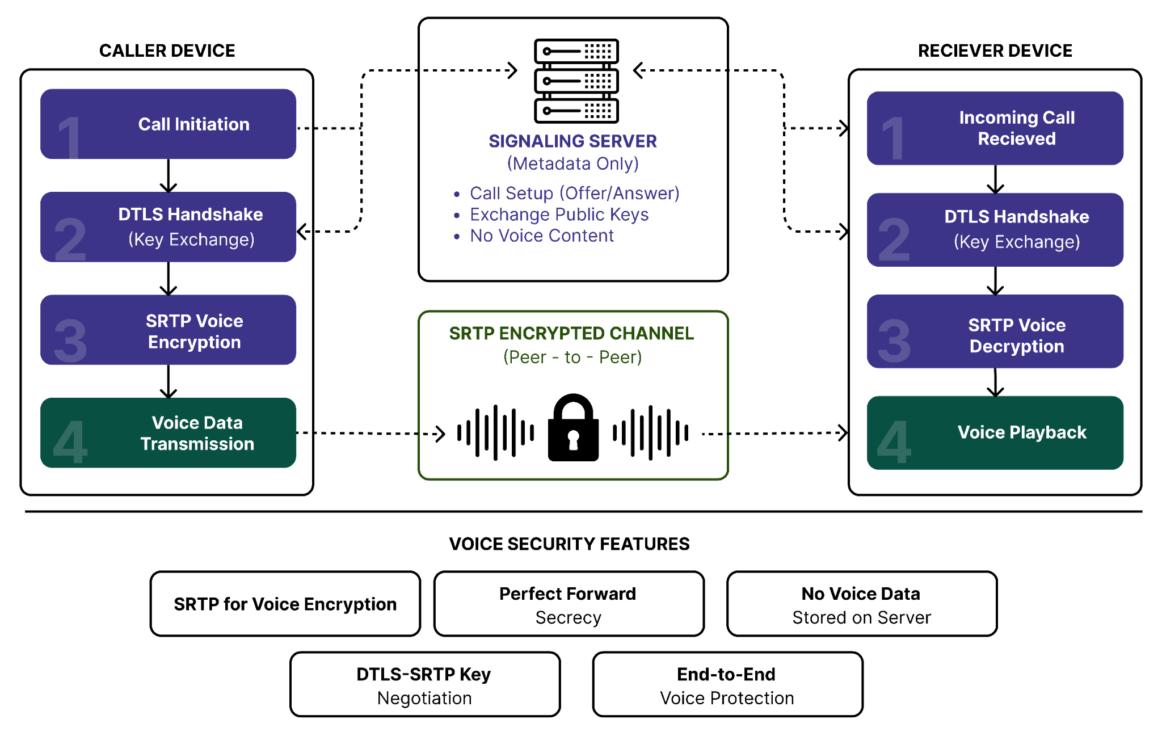

6.2 Call Establishment Procedure
- Step 1
  - Call initiation
- Step 2
  - DTLS handshake
- Step 3
  - ECDHE key exchange
- Step 4
  - SRTP session key generation
- Step 5
  - Encrypted audio transmission
- Step 6
  - Voice playback

6.3 Security Benefits
- End-to-end voice encryption
- Perfect Forward Secrecy
- Secure peer communication
- No server access to voice content

7. Key Management and Exchange
Effective key management is essential to cryptographic security.

7.1 Key Hierarchy

Key Type | Algorithm
Identity Key | X25519
Signed Pre-Key | X25519
One-Time Pre-Key | X25519
Root Key | HKDF
Chain Key | Double Ratchet
Message Key | Double Ratchet

Figure 6 – Key Lifecycle Management
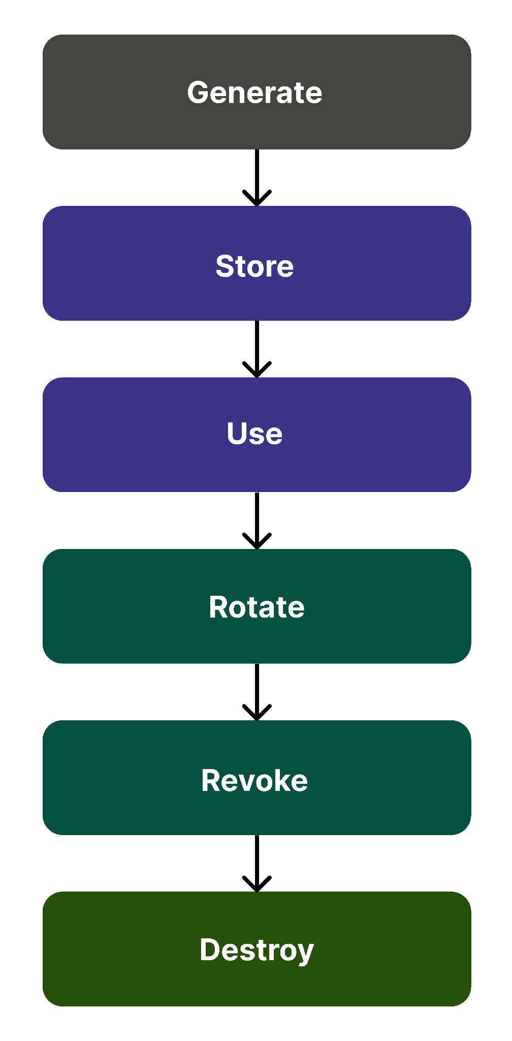

7.2 Key Storage
- Android
  - Android Keystore
- iOS
  - Secure Enclave
- Server
  - Encrypted Key Repository

7.3 Key Rotation
Key | Rotation Period
Signed Pre-Key | 7 Days
One-Time Pre-Key | Automatic
Session Key | Per Session
Message Key | Per Message

7.4 Compromise Response
- If compromise is suspected:
  - Revoke affected keys
  - Generate replacement keys
  - Notify users
  - Re-establish sessions
  - Preserve historical confidentiality through PFS

8. Perfect Forward Secrecy Implementation
- Perfect Forward Secrecy ensures previous communications remain secure even if long-term keys are compromised.

8.1 Technologies Used
  - X3DH
    - Provides secure initial key exchange.
  - Double Ratchet
    - Generates unique message keys.
  - ECDHE
    - Provides ephemeral transport-layer keys.

8.2 Security Benefits
  - Historical message protection
  - Session isolation
  - Reduced compromise impact
  - Future secrecy

9. Encryption Testing and Validation
- Encryption implementation must be verified through practical security testing.

9.1 Testing Environment

Tool | Purpose
MobSF | Mobile Security Assessment
Frida | Runtime Analysis
Burp Suite Community Edition | TLS Verification
Wireshark | Traffic Analysis
OpenSSL | Certificate Validation

9.2 Validation Objectives
- Message Encryption
  - Verify:
    - No plaintext messages visible
    - Signal Protocol active
- TLS Validation
  - Verify:
    - TLS 1.3 enabled
    - ECDHE cipher suites active
- Voice Security
  - Verify:
    - SRTP traffic present
    - No plaintext audio transmitted
- File Security
  - Verify:
    - Files encrypted before upload
    - SQLCipher storage active

9.3 Expected Evidence
- MobSF
  - Encryption assessment
  - Secure storage verification
- Burp Suite
  - TLS handshake verification
  - Certificate validation
- Wireshark
  - Encrypted packet capture
  - Protocol verification
- Frida
  - Runtime encryption validation
  - Key generation verification

Test ID | Test Scenario | Expected Result
ENC-01 | Send encrypted message | Ciphertext only
ENC-02 | Upload encrypted file | Encrypted file stored
ENC-03 | Initiate voice call | SRTP traffic observed
ENC-04 | TLS inspection | TLS 1.3 active
ENC-05 | Session compromise simulation | Historical messages protected

9.4 Success Criteria

Requirement | Expected Result
Message Encryption | No plaintext visible
TLS Security | TLS 1.3 active
File Encryption | AES-256-GCM verified
Voice Security | SRTP verified
Key Management | X3DH + Double Ratchet active

10. Security Considerations

10.1 Potential Risks
- Key Compromise
  - Mitigation:
    - Double Ratchet
    - PFS
- Device Theft
  - Mitigation:
    - Biometrics
    - Secure Enclave
    - Device Encryption

- Man-in-the-Middle Attacks
  - Mitigation:
    - TLS 1.3
    - Certificate Validation
    - Signal Protocol
- Replay Attacks
  - Mitigation:
    - Nonces
    - Session Keys
    - Authentication Tags
- Metadata Exposure
  - Mitigation:
    - Minimal Data Retention
    - Metadata Segregation
    - Future Tor Integration

10.2 Security Standards Alignment

Standard | Purpose
RFC 8446 | TLS 1.3
RFC 3711 | SRTP
Signal Protocol Specification | E2EE
NIST SP 800-57 | Key Management
NIST SP 800-63B | Authentication
OWASP MASVS | Mobile Security

11. Conclusion
- This Encryption Integration Plan defines the implementation of robust cryptographic protections across messaging, voice communication, and file transfers.
- The architecture leverages Signal Protocol, X3DH, Double Ratchet, AES-256-GCM, SRTP, and TLS 1.3 to establish a secure communication platform capable of resisting modern cyber threats.
- Key outcomes include:
  - End-to-end encrypted messaging
  - Secure voice communications
  - Protected file transfers
  - Perfect Forward Secrecy
  - Strong key management
  - Cryptographically verified integrity
  - Comprehensive security testing and validation
- This encryption framework provides a secure foundation for privacy-preserving communication while maintaining scalability, usability, and regulatory compliance.

